**LESSON NOTES COMPOSITION AND COMPREHENSION TERM II**

|  |  |  |  |  |
| --- | --- | --- | --- | --- |
| **Date** | **Time** | **Class** | **No. of pupils** | **Learning Area** |
|  |  | **P.5** |  | **English** |

**THEME : Letter writing**

**SUBTHEME : Composition**

**SKILLS : Listening, speaking, reading, writing**

**Vocabulary**

**Study the meaning of this vocabulary**

|  |  |
| --- | --- |
| * Function * Invite * Chief guest * Celebrate * Address * Envelope * Occasion * Messenger | * Host * Ceremony * Feast * Initiation card * Seal * Postage * Master of ceremonies * Reply |

**Make correct sentences using this vocabulary**

1. letter:…………………………………
2. later:……………………………………..
3. dear:……………………………….
4. deer:……………………………………
5. envelop:………………………………..
6. envelope……………………………….

**Write these abbreviations in full**

1. P.O Box
2. C.C.
3. P.P
4. Ref.
5. BCC
6. R.S.V.P
7. e.g.
8. i.e.
9. N.B
10. e.t.c.
11. 12th
12. 9th
13. Mr.
14. Mrs.
15. Hon.
16. Rev.
17. Dr.

**Use the correct form of the word in bracket to complete the sentences.**

1. The host has………..a good speech (give)
2. Have you ………….the envelope? (seal)
3. Our neighbours will not come because they did not get …………card(invite)
4. All the guests should expect good…………………..at the party (serve)
5. Tom ………….the letter last Wednesday (post)
6. Everybody is ………….to this grand party. (welcome)
7. This ……..is to mark Mukobe’s tenth birthday (celebrate)
8. All ……………..guests will sit in the main hall. (invite)
9. These ……………cost very little money (envelope)
10. Mr. Opio will be our master of ………………(ceremony)
11. My father ………….my letter tomorrow (post)
12. Have you ……..the letter to the county Chief? (write)
13. I cannot see the writer’s ……………….in this letter (sign)
14. Bob has ……………his sister’s letter today (reply)
15. Have you ……………….. the parcel by air? (send)
16. I ……………….. my letter yesterday. (envelop)

**Re-write these sentences giving one word for the underlined group of words**

1. Sam did not write back to my letter.
2. The letter was not put in the envelop.

|  |  |  |  |  |
| --- | --- | --- | --- | --- |
| **Date** | **Time** | **Class** | **No. of pupils** | **Learning Area** |
|  |  | **P.5** |  | **English** |

**THEME : Letter writing**

**SUBTHEME : Composition**

**SKILLS : Listening, speaking, reading, writing**

**Spelling activity**

1. Pronounce - pronunciation
2. Explain – explanation
3. Maintain – maintenance
4. Safe – safety
5. Thief – theft

**Using:…………………, so………………………..**

**because**

**Example**

1. Linda is sick. She cannot attend the party.

Linda is sick so she cannot attend the party.

1. George didn’t invite me. I did not attend the party.

George didn’t invite me, so I did not attend the party.

**Exercise**

**Join these sentences using:……………………….so………………**

1. I paid less money. She did not give me the stamp.
2. The letter was untidy. Mary could not send it.
3. The programme is incomplete. We cannot recommend it.
4. He made a big party. Karamagi graduated at Makerere University.
5. He has to attend the function. Olum is the guest of honour.
6. The invitation cards were ready. Messengers took them to the officers.
7. The programme is incomplete. We cannot recommend it.
8. Suzan sent the letter. She waited for a reply.
9. Everybody went home. The function was over.
10. He invited many family friends. It was Karungi’s birthday.

|  |  |  |  |  |
| --- | --- | --- | --- | --- |
| **Date** | **Time** | **Class** | **No. of pupils** | **Learning Area** |
|  |  | **P.5** |  | **English** |

**THEME : Letter writing**

**SUBTHEME : Comprehension**

**SKILLS : Listening, speaking, reading, writing**

**Spelling activity**

1. permit – permission
2. admit – admission
3. decide – decision
4. wise – wisdom
5. enemy – enmity

**Dialogue**

**Read the dialogue and answer the questions that follow**

**(MK Primary pupils book 5 page 92 – 93)**

**My First letter**

Sandra : Tell me, when did you write your first letter?

Peter : At the end of the first term in Primary four

Sandra : Who did you write to?

Peter : Mu mother.

Sandra : Your mother? Why did you have to write?..............continued................

**Questions**

1. How many people are taking part in the dialogue?
2. What is the dialogue about?
3. When did Peter write his first letter?
4. To whom did Peter write?
5. Why did Peter have to write?
6. Who took Peter’s letter according to the dialogue?
7. Who are the people taking part in the dialogue?
8. What is the title of the dialogue?
9. Did Peter’s mother send the books?
10. According to the dialogue why did Peter travel to Jinja?

|  |  |  |  |  |
| --- | --- | --- | --- | --- |
| **Date** | **Time** | **Class** | **No. of pupils** | **Learning Area** |
|  |  | **P.5** |  | **English** |

**THEME : Letter writing**

**SUBTHEME : Comprehension**

**SKILLS : Listening, speaking, reading, writing**

**( MK Primary Eng book 5 page 96 – 97)**

**Spelling activity**

1. lady's bag – ladies’ bags
2. baby’s toy – babies’ toys
3. passer-by – passers-by
4. chief – chiefs

**A friendly letter**

**Read the letter below carefully and answer questions about it in full sentences.**

**LOHANA ACADEMY**

**P.O BOX 48,**

**KAMPALA,**

**10th April, 2012.**

Dear Nantongo,

Thank you for your letter dated 1st August, 2012. I received it after a week. Our mail box is in town. My parents do not travel to the city often. That is why I received the letter after a week. We shall break up for holidays on the 29th August. I would very much like to spend the holiday at Nabugabo beach near Lake Victoria. I have been here for only six months but I have experienced a lot. Our teachers are good and we have enough text books.

I am sorry, I would like to end here. We shall discuss the rest when we meet. May the good Lord keep you safe.

Yours friend,

**Christ Mujuni**

**Questions**

1. What is the nearest city to Chris Mujuni?
2. To whom was the letter written?
3. Where is Nabugabo beach found?
4. Who wrote this letter?
5. Where does the writer hope to spend the holidays?
6. Who is in a new school?
7. When did Christ Mujuni write this letter?
8. What school does Kamu Peter attend?
9. Who wrote a letter dated 1st August?
10. Why do you think Mujuni received the letter a week after it had been sent?

|  |  |  |  |  |
| --- | --- | --- | --- | --- |
| **Date** | **Time** | **Class** | **No. of pupils** | **Learning Area** |
|  |  | **P.5** |  | **English** |

**THEME : Letter writing**

**SUBTHEME : Composition**

**SKILLS : Listening, speaking, reading, writing**

**Spelling activity**

1. shabby - shabbily
2. greedy – greedily
3. hurry – hurriedly
4. bad – badly
5. polite – politely

**Writing a personal letter**

**Read some facts about writing a personal letter (friendly letter)**

1. The writer’s address is written first.

**Examples**

e.g Aduku Primary School

P.O Box 272,

Gulu

1. Date: 30th June 2011
2. Greeting: Dear Byansi
3. Body : Message to the addressee (one receiving the letter)
4. Ending the letter e.g your friend
5. Writers name

**Exercise**

Write a letter to your friend telling him / her about your school, the day you will close the term and where you will spend the holiday.

|  |  |  |  |  |
| --- | --- | --- | --- | --- |
| **Date** | **Time** | **Class** | **No. of pupils** | **Learning Area** |
|  |  | **P.5** |  | **English** |

**THEME : Letter writing**

**SUBTHEME : Composition**

**SKILLS : Listening, speaking, reading, writing**

**Spelling activity**

1. dirty dirtied
2. smooth – smoothed
3. tidy – tidied
4. pay – paid
5. fly – flew
6. ride – rode

**Writing a friendly letter**

***Re-arrange these sentences to write a short letter.***

1. Natukunda Edson.
2. How are you and how are the holidays?
3. Your friend,
4. Buganda Road Primary School
5. Kampala
6. Dear Magezi,
7. So, don’t expect to see me at grandmother’s place.
8. I am writing to tell you that I will be travelling to Nairobi these holidays
9. 14th July 2011
10. I wish you good holidays.
11. P.O Box 2264
12. I will spend two weeks there.

|  |  |  |  |  |
| --- | --- | --- | --- | --- |
| **Date** | **Time** | **Class** | **No. of pupils** | **Learning Area** |
|  |  | **P.5** |  | **English** |

**THEME : Letter writing**

**SUBTHEME : Composition**

**SKILLS : Listening, speaking, reading, writing**

**Invitation letter**

**Write a letter to your friend inviting him to attend your birthday party. Tell him the date, time and the place where it will take place.**

|  |  |  |  |  |
| --- | --- | --- | --- | --- |
| **Date** | **Time** | **Class** | **No. of pupils** | **Learning Area** |
|  |  | **P.5** |  | **English** |

**THEME : Letter writing**

**SUBTHEME : Comprehension**

**SKILLS : Listening, speaking, reading, writing**

**Study the invitation card below and answer questions about it.**

The family of Mr. and Mrs. Juliet Wambuga of Buwasa village, together with the family of Mr. and Mrs. Maureen Matega of Lambala, luuka district

With pleasure iinvites the company of

Mr. /Mrs./ Dr./ Bishop/ Rev√

GODFREY MANDA

to the wedding ceremony of their children

CHARLES MATOVU AND IRENE MIREMBE

Which will take place on Saturday 25th April, 2011 at 2:00pm at St. Phillip and Andrew Cathedral Mukono and thereafter to a reception at Satellite beach

R.S.V.P (regrets only)

Mr. Kasumba Jamil Mr. Malinzi Bench

Tel. 0782 334534 Tel. 0752 567348

**Questions**

1. What is the invitation card about?
2. What day will the function take place?
3. Who are going to wed?
4. When should Reverend Godfrey telephone Mr. Kasumba?
5. Where does the family of Moureen Matega stay?
6. Where will the reception be held?
7. What time will the function start at the church?
8. To whom can you reply in case you will not attend?
9. Write in full
   1. R.S.V.P
   2. Rev.

|  |  |  |  |  |
| --- | --- | --- | --- | --- |
| **Date** | **Time** | **Class** | **No. of pupils** | **Learning Area** |
|  |  | **P.5** |  | **English** |

**THEME : Letter writing**

**SUBTHEME : Comprehension**

**SKILLS : Listening, speaking, reading, writing**

**Passage**

**Read the passage carefully and answer questions about it in full sentences. (MK P.5 pg 164)**

**Personal letters and Invitations**

**Questions**

1. What is the passage about?
2. Write the other name for a personal letter
3. Why do we write personal letter?
4. What should a personal letter show?
5. What should you do before sealing the letter?
6. What is the importance of plot number on some letters?
7. Who is an addressee?
8. Which word can be used instead of destination?
9. Why should letters be written in good handwriting?
10. What should an address have?

|  |  |  |  |  |
| --- | --- | --- | --- | --- |
| **Date** | **Time** | **Class** | **No. of pupils** | **Learning Area** |
|  |  | **P.5** |  | **English** |

**THEME : Letter writing**

**SUBTHEME : Composition**

**SKILLS : Listening, speaking, reading, writing**

**Picture composition**

**Study the pictures and answer questions on them. (MK P.5 pg 164)**

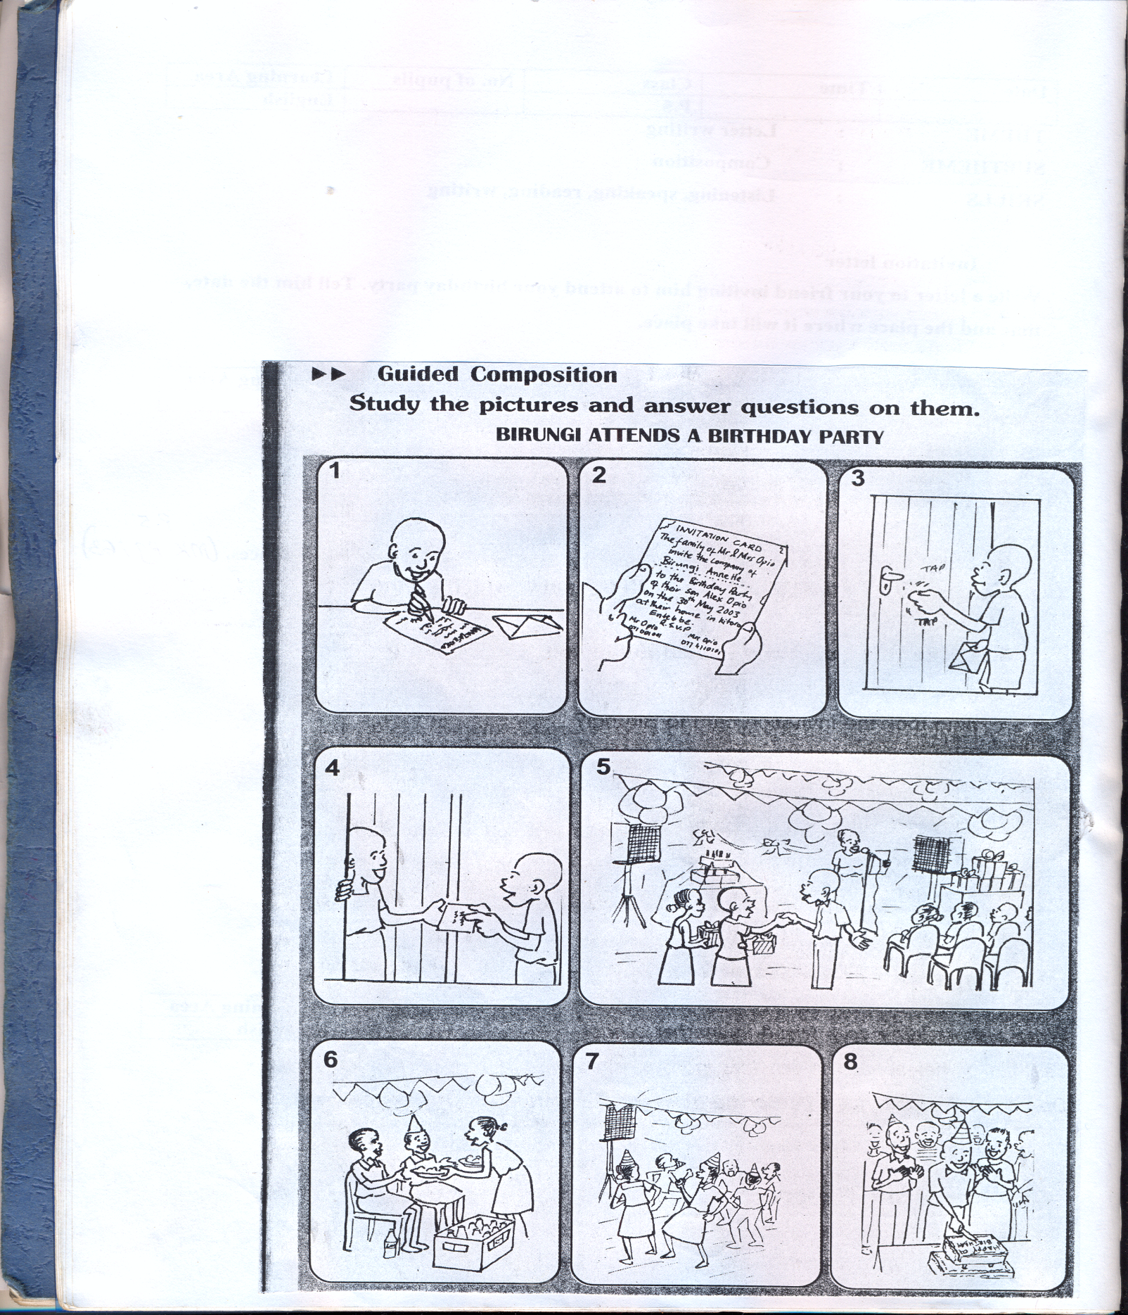**BIRUNGI ATTENDS A BIRTHDAY PARTY**

1. Write correct sentence about each picture describing what is happening. You can use these words

write , welcome , read , serve , dance , take , deliver , cake

Picture 1 Picture 2 Picture 3

Picture 4 Picture 5 Picture 6

|  |  |  |  |  |
| --- | --- | --- | --- | --- |
| **Date** | **Time** | **Class** | **No. of pupils** | **Learning Area** |
|  |  | **P.5** |  | **English** |

**THEME : Letter writing**

**SUBTHEME : Composition**

**SKILLS : Listening, speaking, reading, writing**

**Composition writing**

**Write a short story about a birthday party which Birungi attended.**

**The following questions should guide**

* Who invited Birungi to a birthday party?
* Who took the invitation card to Birungi
* Why was the party held
* What did Birungi give to her friend?
* Who danced at the party?
* Why did Opio’s friends wear hats?
* Why is it good to invite friends?

|  |  |  |  |  |
| --- | --- | --- | --- | --- |
| **Date** | **Time** | **Class** | **No. of pupils** | **Learning Area** |
|  |  | **P.5** |  | **English** |

**THEME : Communication**

**SUBTHEME : Jumbled composition**

**SKILLS : Listening, speaking, reading, writing**

**Spelling activity**

1. shy – shyer
2. ugly – uglier
3. bad – worse
4. cruel – crueler
5. clever – cleverer

**Re-arrange the following sentences to form a correct story**

1. ***Lastly, if your letter is not in the envelope, it will not be posted.***
2. ***These stamps are only bought at the post office.***
3. ***If the box number is not correct, your***
4. ***It will not be posted to the person you want.***
5. ***Unless you put a stamp on your letter,***
6. ***delay to reach the right person***
7. ***Another point to remember is that the***
8. ***This is because the post office does not handle unstamped letters.***
9. ***Letter may be posted to another person or***
10. ***Box number must be correct and clear***

|  |  |  |  |  |
| --- | --- | --- | --- | --- |
| **Date** | **Time** | **Class** | **No. of pupils** | **Learning Area** |
|  |  | **P.5** |  | **English** |

**THEME : Communication**

**SUBTHEME : Telephone**

**SKILLS : Listening, speaking, reading, writing**

**Vocabulary**

**Study this vocabulary carefully.**

|  |  |
| --- | --- |
| * Money order * Postage * Aerogram * Telegram * Phone counter | * Registered mail * Air time * Landline * Teleface * Scroll * SMS |

**Make correct sentences using this vocabulary.**

1. both :………………………………….
2. booth:………………………………….
3. Airtime ……………………………………
4. Website …………………………………… both booth
5. Telephone ………………………………...

**Write these abbreviations in full**

1. PIN
2. SIM
3. SOS
4. SMS
5. MB
6. GB
7. KB
8. Tel.

**Use the correct form of the words in bracket**

1. Mrs. Kapere …………the letters yesterday (post)
2. I ………………….. a letter to my friend now (write)
3. We were taught to write …………… on letters clearly(address)
4. Gidudu ……………….the money by money order last week(send)
5. Mulindwa will buy two……………in order to post the letters (stamp)
6. Mr. Balaka, the post master,……………..workers every Friday.(pay)
7. Shamim went to the telephone both and …………..her sister from there. (ring)
8. ………………..are sold at the post office (token)
9. My sister…………………a call to our father using Musa’s mobile phone last evening (make)

|  |  |  |  |  |
| --- | --- | --- | --- | --- |
| **Date** | **Time** | **Class** | **No. of pupils** | **Learning Area** |
|  |  | **P.5** |  | **English** |

**THEME : Communication**

**SUBTHEME : The Post office**

**SKILLS : Listening, speaking, reading, writing**

**Spelling activity**

1. prefer – preferred
2. mop – mopped
3. drive – drove
4. broad cast – broad cast
5. telecast – telecast

**Using: Either ……………………or …………………..**

1. Peter will post a letter. John will post the letter.

Either Peter or John will post the letter.

1. The teacher went the post office. The pupils went to the post office.

Either the teacher or the pupils went to the post office.

**Exercise**

**Join these sentences using: Either ………or…………**

1. They will write a letter to their father.

They will write a letter to their mother.

1. James bought the airtime.

Ivan bought the air time.

1. Sarah sealed the parcel.

Jane sealed the parcel.

1. My father can use internet.

My uncle can use internet

1. The post office is near our home.

The aerogram is near our home.

1. Our class teacher wrote the address. ***Our class teacher wrote the dates***
2. The post master will visit us.

The bank manager will visit us.

1. A mobile phone is expensive.

A landline is expensive.

1. Tom bought two envelopes.

Nagenda bought two envelopes.

1. John replied to the letter.

Matovu replied to the letter.

**Using …………………either ………………….or …………………….**

**Examples**

1. James will play football. James will play volley ball.

James will play either football or volley ball.

1. Simon will travel by a bus. Simon will travel by a taxi.

Simon will travel either by a bus or by a taxi.

**Exercise**

1. The pedestrian will send a letter. The pedestrian will send an e-mail.

(Use…………….either……………………. or ………………………)

1. Peter can help his father. Peter can help his mother.

(Use…………….either……………………. or ………………………)

1. The post mistress will receive the money. The post mistress will receive the parcel.
2. The conductor went to the booth. The conductor went to the post office
3. Suzan will envelope the letter. Suzan will seal the letter.
4. My father bought a directory. My father bought a diary.
5. I will go to the internet café. I will go to the hospital.
6. Ivan will break the SIM card. Ivan will break the ATM card.

|  |  |  |  |  |
| --- | --- | --- | --- | --- |
| **Date** | **Time** | **Class** | **No. of pupils** | **Learning Area** |
|  |  | **P.5** |  | **English** |

**THEME : Communication**

**SUBTHEME : The Post office**

**SKILLS : Listening, speaking, reading, writing**

**Spelling activity**

1. dynamo - dynamos
2. radio – radios
3. photo – photos
4. potato – potatoes
5. chimney – chimneys

**Use: of …………….unless …………………**

**Examples**

1. Your letter will not be posted if you don’t fix a postage stamp.

Your letter will not be posted unless you fix a postage stamp

**Exercise**

**Re-write these sentences using unless**

1. If you buy a stamp, you will be able to post your letter.
2. If you get air time, you will be able to communicate to your sister.
3. If my father buys a telephone, I will learn to telephone to my friends.
4. If my sister doest get to the post office, she will not get the parcel.
5. If you pay for your box rental, it will not be closed.
6. If I get money. I will send the e-mail to my grandmother in London.
7. If I learn to load airtime on this phone, I will send SMS to my friend.

|  |  |  |  |  |
| --- | --- | --- | --- | --- |
| **Date** | **Time** | **Class** | **No. of pupils** | **Learning Area** |
|  |  | **P.5** |  | **English** |

**THEME : Communication**

**SUBTHEME : The Telephone**

**SKILLS : Listening, speaking, reading, writing**

**Using: ……………needn’t ………….**

**Examples**

1. It is not necessary for you to own a telephone.

You needn’t own a directory.

1. It is not necessary for you to send SMS now.

You needn’t send SMS now.

**Exercise**

1. It is not necessary for you to post that letter.
2. It is not necessary for my father to buy that expensive telephone.
3. It is not necessary for my uncle to telephone to my cousin.
4. It is not necessary for Sam to own two telephones.
5. It is not necessary for Peter to dial a wrong number.

|  |  |  |  |  |
| --- | --- | --- | --- | --- |
| **Date** | **Time** | **Class** | **No. of pupils** | **Learning Area** |
|  |  | **P.5** |  | **English** |

**THEME : Communication**

**SUBTHEME : The Telephone**

**SKILLS : Listening, speaking, reading, writing**

**Use each of the given words in a sentence to show that you know the difference in the meaning**

1. load
2. road
3. mast
4. must

**Using ………..need to ………….**

1. It is necessary for you to fix a land line at home.

You need to fix a landline at home.

**Exercise**

1. It is necessary for you to buy airtime cards.
2. It is necessary for Denis to call the police.
3. It is necessary for my father to buy a mobile telephone.
4. It is necessary for Andrew to telephone to me.
5. It is necessary for Joan to sell airtime.

**Re-write these sentences using a single word for the underlined group of words**

1. The part on a phone put near the mouth when making a call is spoilt.
2. The part on a phone put near the ear when making a call has been repaired.
3. The machine used for talking to someone over a distance was stolen last week.

|  |  |  |  |  |
| --- | --- | --- | --- | --- |
| ***Date*** | ***Time*** | ***Class*** | ***No. of pupils*** | ***Learning Area*** |
|  |  | ***P.5*** |  | ***English*** |

***THEME : Communication***

***SUBTHEME : The Telephone***

***SKILLS : Listening, speaking, reading, writing***

***Using ………..needn’t have ………….***

***Examples***

1. *It was not necessary for you to buy a landline at school.*

*You needn’t have bought a landline at school.*

1. *It was not necessary for my uncle to talk to me on phone.*

*My uncle needn’t have talked to her on phone.*

***Exercise***

1. *It was not necessary for Joan to receive the parcel.*
2. *It was not necessary for Bob to buy a new phone.*
3. *It was not necessary for my mother to write to me.*
4. *It was not necessary for him to recite multiplication tables.*
5. *It was not necessary for Kwezi to sell that diary.*
6. *It was not necessary for the traffic officer to sell airtime.*
7. *It was not necessary for Kwizera to fix a land line.*
8. *It was not necessary for Mildred to send me an SMS.*

|  |  |  |  |  |
| --- | --- | --- | --- | --- |
| **Date** | **Time** | **Class** | **No. of pupils** | **Learning Area** |
|  |  | **P.5** |  | **English** |

**THEME : Communication**

**SUBTHEME : Composition**

**SKILLS : Listening, speaking, reading, writing**

**Study the information carefully and complete the table below. (MK BK 5 pg.191)**

**INFORMATION:**

Miss Namazzi Sarah is a nurse at Kiboga Hospital. The Post Office Box number of this hospital is 111 at Kiboga Post Office. She received a registered parcel on the 12th April, 2000 from Kabale. The number of the parcel was 1166. She went with her identity card to collect her parcel. Her identify card number is 1232.

**Study the information about the calls Mr. Tubanze made and answer the questions that follow in full sentences**

**(St. Bernard English book 5 page 113)**

|  |  |  |
| --- | --- | --- |
| **Name of person called** | **Number of receiver** | **Time of call** |
| Oketa | 0414654312 | 8:00am |
| Isiiko | 0772467436 | 9:00am |
| Nsimbi | 0712123321 | 9:33am |
| Alutuwa | 0752354908 | 10:18am |
| Musabi | 0795786540 | 11:00am |
| Emejje | 0706709853 | 11:46am |
| Ibanda | 0412590643 | 2:00pm |

............continued...................

**Questions**

1. What is the information about?
2. How many calls did Mr. Tubenza make?
3. Who was the first person to be called?
4. Which number did he call at 10:18am?
5. How many people did Mr. Tubenza call that day?
6. At what time did he call Apuuli?
7. Whose telephone number is 0712123321?
8. Write in full
   1. a.m
   2. Tel
9. Suggest a suitable title to the above information.

|  |  |  |  |  |
| --- | --- | --- | --- | --- |
| **Date** | **Time** | **Class** | **No. of pupils** | **Learning Area** |
|  |  | **P.5** |  | **English** |

**THEME : Communication**

**SUBTHEME : Comprehension**

**SKILLS : Listening, speaking, reading, writing**

**Notice**

**Study one page from the telephone directory and answer questions about it. (MK BK5 pg 193)**

Bafana Enterprises, New Kitoolo Taxi Park,

P.O.Box 277, Entebbe

Tel…………………....235707

Berinda Peace,

P.O.Box 670, Mbale.

Tel…………………...286031

Birindi Primary School,

P.O Box 444, Lira,

Tel……………………270078

Byafu Toto Ltd.,

Plot 29/33, Jinja road,

P.O.Box 222 Kampala

Tel…………………….234410

Akello Elizabeth,

P.O.Box 1987, Kampala

Tel……….……..236302

Akello Jesca,

P.O.Box 11220,

Tel……………...231264

Akiba Development Co,

P.O Box 888, Mbarara,

Tel…………..…234567

Akina Maama wa Africa,

Plot 204, Kisugu

P.O.Box 241 Kampala

Tel………….….289765

**Question**

1. Whose telephone number is 231264?
2. Whose Post office Box number is 444?
3. Which post office Box number will you use to write to Berinda peace?
4. Where can you find Byafu Toto Ltd?
5. On which plot is Akin’a Maama wa Africa found?
6. Which school is found in Lira?
7. In which town is Bafana Enterprises found?
8. How will you address a letter to Akiba Development Company?
9. Write in full.
10. SMS
11. P.O
12. Ltd.

|  |  |  |  |  |
| --- | --- | --- | --- | --- |
| **Date** | **Time** | **Class** | **No. of pupils** | **Learning Area** |
|  |  | **P.5** |  | **English** |

**THEME : Communication**

**SUBTHEME : Comprehension**

**SKILLS : Listening, speaking, reading, writing**

**Dialogue**

**Read the dialogue between “Charles and Keneth and answer the questions about it in full sentences. St. Bernard Eng book 5 page 107)**

**999 help line**

Charles : Help please, Keneth help! Our house is on fire! May I use your phone?

Keneth : Whom do you want to call?

Charles : The police! We need the fire brigade.

Keneth : Sorry! I don’t have airtime on my phone.

Charles : Don’t mind. I am going to dial 999 police help line. It is free of charge.

Keneth : Here is the telephone. Call now to get help

Charles : Thank you. Fire brigade is on the way.

Keneth : We need to call police help line whenever there is danger.

**Questions**

1. How many people are taking part in the dialogue?
2. Whose house was on fire?
3. What is the dialogue about?
4. Whom did Keneth call?
5. Why did Keneth make the call to the police?
6. Which number did Keneth dial?
7. Who are the people taking part in the dialogue?

|  |  |  |  |  |
| --- | --- | --- | --- | --- |
| **Date** | **Time** | **Class** | **No. of pupils** | **Learning Area** |
|  |  | **P.5** |  | **English** |

**THEME : Communication**

**SUBTHEME : Comprehension**

**SKILLS : Listening, speaking, reading, writing**

**Passage**

**Read the story carefully and answer questions about it in full sentences.**

**(Integrated English book 5 page 65 – 66)**

**A visit to the post office**

Nabukalu was an affectionate friend of Nakalembe when they were still in primary four last year. At the beginning of this year, Nakalembe changed school. She was taken by her parents to Jinja parents school

...........continued...................

**Questions**

1. When did Nakalembe transferred to Jinja parents school?
2. What is the passage about?
3. How much did Nabukaly pay for the stamp?
4. What is the title of the passage?
5. What is a parcel according to the passage?
6. Who was Nakalembe’s friend?
7. Of what use was a directory to Nabukalu?
8. What else dd Nabukalu want to send to her friend?

|  |  |  |  |  |
| --- | --- | --- | --- | --- |
| **Date** | **Time** | **Class** | **No. of pupils** | **Learning Area** |
|  |  | **P.5** |  | **English** |

**THEME : Communication**

**SUBTHEME : Composition**

**SKILLS : Listening, speaking, reading, writing**

**Picture composition**

**Study the pictures carefully and answer questions about it.**

**POSTING LETTERS**

**(St. Bernard English book 5 page 102)**

**Question**

1. Write, a sentence about each picture describing what is happening

These words may guide you

|  |  |  |
| --- | --- | --- |
| * writing * post office | * Envelope * Slot | * sealing * home * going |

Picture A

Picture B

Picture C

Picture D

Picture E

Picture F

1. What items do you see in picture A?
2. Why is it a bad practice to seal an envelope using your tongue?
3. What is the boy in picture B?

|  |  |  |  |  |
| --- | --- | --- | --- | --- |
| **Date** | **Time** | **Class** | **No. of pupils** | **Learning Area** |
|  |  | **P.5** |  | **English** |

**THEME : Communication**

**SUBTHEME : The Internet**

**SKILLS : Listening, speaking, reading, writing**

**Vocabulary**

Email, website, delete, sum, open, scroll, folder, surfing, computer, internet café, service fee, virus, sign in, sign out log, search, engine, yahoo, Google, internet, explorer

**Exercise**

**Make correct sentences using the words given below.**

1. sign in
2. delete
3. surfing
4. scroll
5. folder

|  |  |  |  |  |
| --- | --- | --- | --- | --- |
| ***Date*** | ***Time*** | ***Class*** | ***No. of pupils*** | ***Learning Area*** |
|  |  | ***P.5*** |  | ***English*** |

***THEME : Communication***

***SUBTHEME : Composition***

***SKILLS : Listening, speaking, reading, writing***

**Spelling activity**

1. proud – pride
2. wise – wisdom
3. cruel – cruelty
4. guilty – guilt

***Using: ____too _____ to _______***

***Examples***

1. *The internet café was very busy. I could not check on my e – mail.*

*The internet café was too busy for me to check on my e-mail.*

***Exercise***

1. *My father is very poor. He cannot buy a new telephone.*
2. *The website is very busy. Joan cannot access her e-mail.*
3. *She is very rich. She can buy that computer.*
4. *Achebe was very late. She could not meet the mechanic.*
5. *Katama was very slow. She could not remove the virus from the computer.*
6. *He is very tired. He cannot go to the internet café.*
7. *They were very late. They could not talk to the postmaster.*
8. *My aunt is very happy. She cannot continue surfing.*

|  |  |  |  |  |
| --- | --- | --- | --- | --- |
| **Date** | **Time** | **Class** | **No. of pupils** | **Learning Area** |
|  |  | **P.5** |  | **English** |

**THEME : Communication**

**SUBTHEME : Composition**

**SKILLS : Listening, speaking, reading, writing**

**Using: a) ____so as _____ b) in order ___ c) such that/ so that ___**

**Examples**

1. He logged onto yahoo. He wanted to surf news.

He logged onto yahoo so as to surf news.

**Exercise**

**Join these sentences using ____so as ____**

1. He entered the internet café. He wanted to check on his e-mail.
2. He deleted all the information. He wanted to create space in the box.
3. I opened the website. I wanted to access my e-mail
4. *Hennery went to the post office. He wanted to receive his parcel.*
5. *They bought a new computer. They wanted to record all the information.*
6. *He bought a directory. He wanted to save all his addresses.*
7. *Okurut opened the internet. She wanted to chat with her son.*
8. *Sarah visited the website. She wanted to surf news.*

|  |  |  |  |  |
| --- | --- | --- | --- | --- |
| **Date** | **Time** | **Class** | **No. of pupils** | **Learning Area** |
|  |  | **P.5** |  | **English** |

**THEME : Culture (*Nationality)***

**SUBTHEME : Composition**

**SKILLS : Listening, speaking, reading, writing**

**Vocabulary**

**Study the meaning of these vocabulary carefully.**

|  |  |
| --- | --- |
| * Citizen * Ugandan * Kenyan * Tanzania * German * Scottish | * Foreign * Foreigner * France * English * Indian * Ghanaian |

**Study the countries and their citizen.**

|  |  |
| --- | --- |
| **Country** | **Citizen** |
| Uganda  Kenya  Congo  Sudan  Nigeria  Libya  Malawi  Britain  Ethiopia  Zambia  Brazil  China | Ugandan  Kenyan  Congolese  Sudanese  Nigerian  Libyan  Malawian  British  Ethiopian  Zambian  Brazilian  Chinese |

**Exercise**

**Use the correct form of words in bracket to complete the sentences.**

1. We stayed with some ………..nationals when we went scouting (America)
2. Achebe is a …………..living in Logos (Nigeria)
3. That lady, Susanne, is a ………………….(Germany)
4. Our teacher was called as ……..when he went abroad .(foreign)
5. There are some …………business women in Busia.
6. There are some …………living in Zambia (Rwanda)
7. Mr. Balinda is a ………living in Rwanda (Uganda)
8. There are some …………………studying in our school (Tanzania)
9. My father has lived with ………………..nations for a long time.(France)
10. Suzan’s mother does not live here, she ……………………..abroad.(live)

|  |  |  |  |  |
| --- | --- | --- | --- | --- |
| **Date** | **Time** | **Class** | **No. of pupils** | **Learning Area** |
|  |  | **P.5** |  | **English** |

**THEME : Culture**

**SUBTHEME : Composition**

**SKILLS : Listening, speaking, reading, writing**

**Spelling activity**

1. Rwanda – Rwandan
2. Ghana – Ghanaian
3. Morocco – Moroccan
4. China – Chinese
5. Germany – German

**Structures**

**Using “ I am from …………………I am a……………………….**

1. Officer: Lumu, where are you from and what is your nationality?

Lumu: I am from Uganda, I am Ugandan.

1. Officer: Mboya, where are you from and what is your nationality?

Mboya: I am from Kenya, I am a Kenyan.

**Exercise**

**Following the examples above, write the answers given by different people to the officer’s question below. Use the words in brackets**

1. Kaitesi, Where are you from and what is your nationality? (Rwanda)
2. Soyinka, where are you from and what is your nationality (Nigeria)
3. Bugwa, where are you from and what is your nationality (Kenya)
4. Bozo, where are you from and what is your nationality? (Zimbabwe)
5. Lalifa, where are you from and what is your nationality? (Libya)
6. Kofi, where are you from and what is your nationality?(Ghana)
7. Pailina, where are you from and what is your nationality?(Italy)
8. Moliere, where are you from and what is your nationality?(France)
9. Wang, where are you from and what is your nationality (China)
10. Letel , where are you from and what is your nationality (India)

|  |  |  |  |  |
| --- | --- | --- | --- | --- |
| **Date** | **Time** | **Class** | **No. of pupils** | **Learning Area** |
|  |  | **P.5** |  | **English** |

**THEME : Culture**

**SUBTHEME : Comprehension**

**SKILLS : Listening, speaking, reading, writing**

**Dialogue**

**Read the dialogue between “Stella and Abdu” and answer questions about it. (MK BK5 pg 145)**

Stella : May I look at your papers, please?

Abdu : Yes, please. Here they are.

Stella : Do you come from Syria?

Abdu : Yes, I do, I am a Syrian.

Stella : I heard you speaking French. I thought you come from France.

Abdu : Not at all. I speak French because I grew up in France.

Stella : What about your friends?

Abdu : They are Italians but they understand French. That’s why I use French when

talking to them.

Stella : How long will you stay in Kenya?

Abdu : A fortnight.

Stella : You are welcome to our country. I hope you will enjoy your stay here.

Abdu : I already feel at home. Thank you.

**Questions**

1. What is Abdu’s nationality?
2. How many people are taking part in the dialogue?
3. What is the dialogue about?
4. Name two languages Abdu can speak.
5. Where do Abdu’s friends come from?
6. What language do Abdu’s friends speak?
7. Why is Abdu able to speak French?
8. What is Stella’s nationality?
9. Give a title to the dialogue.

|  |  |  |  |  |
| --- | --- | --- | --- | --- |
| **Date** | **Time** | **Class** | **No. of pupils** | **Learning Area** |
|  |  | **P.5** |  | **English** |

**THEME : Culture**

**SUBTHEME : Comprehension**

**SKILLS : Listening, speaking, reading, writing**

**Passage**

**Read the passage carefully and answer questions about it in full sentences. (MK BK5 pg 146 -147)**

**A Feast for all Nationalities**

Sports activities bring many nationalities together. In the newspapers we read about events like “Bika Football League”, “Inter University Games Tournament”, “Africa cup of Nations”, “World Cup”, and many others.

Whether at national or international levels, games attract many people of different origins. Many people from all over Africa take part in games. Abel Mreta comes from Tanzania , Violet Mburu is a Kenyan, Lucia Dogbeh is from Benin, Peninah Nzaramba is from Rwanda , Denis Obua is from Uganda, Steven Biko is from South Africa, Paulo Onovoh is from Nigeria and Yipene is from Burkina Faso. It is an occasion; a feast to which many people come to celebrate.

A good example of the moment when people come together is the “World Cup”.

**Questions**

1. What is the passage about?
2. What is your nationality?
3. Who is a Rwandese?
4. Why do these people meet in one place?
5. Which player comes from Cameroon?
6. What nationality is Mburu?
7. What do we call people from Germany?
8. What nationality is Romarlio?
9. Which country does Oliver come from?

|  |  |  |  |  |
| --- | --- | --- | --- | --- |
| **Date** | **Time** | **Class** | **No. of pupils** | **Learning Area** |
|  |  | **P.5** |  | **English** |

**THEME : Culture**

**SUBTHEME : Composition**

**SKILLS : Listening, speaking, reading, writing**

**Write a composition by answering these questions**

1. What is your name?
2. What is your parent’s name?
3. Which school do you go to?
4. In which district is it found?
5. In which country is this district?
6. Are you a Ugandan or not?
7. If you aren’t a Ugandan, what nationality are you?
8. What is the name of your best friend?
9. Is he a Ugandan or a foreigner?
10. From which country does he come?
11. Are there many pupils from other countries in your school?
12. Are there many pupils from overseas countries?
13. Which countries are bordering Uganda?
14. What people live in those countries?
15. Are they nice people?
16. Would you like to visit them?

|  |  |  |  |  |
| --- | --- | --- | --- | --- |
| **Date** | **Time** | **Class** | **No. of pupils** | **Learning Area** |
|  |  | **P.5** |  | **English** |

**THEME : Culture**

**SUBTHEME : Composition**

**SKILLS : Listening, speaking, reading, writing**

**Picture composition**

**Study the pictures and answer questions that follow. (MK BK 5 pg 149)**

**Friendly competitions in South Africa**

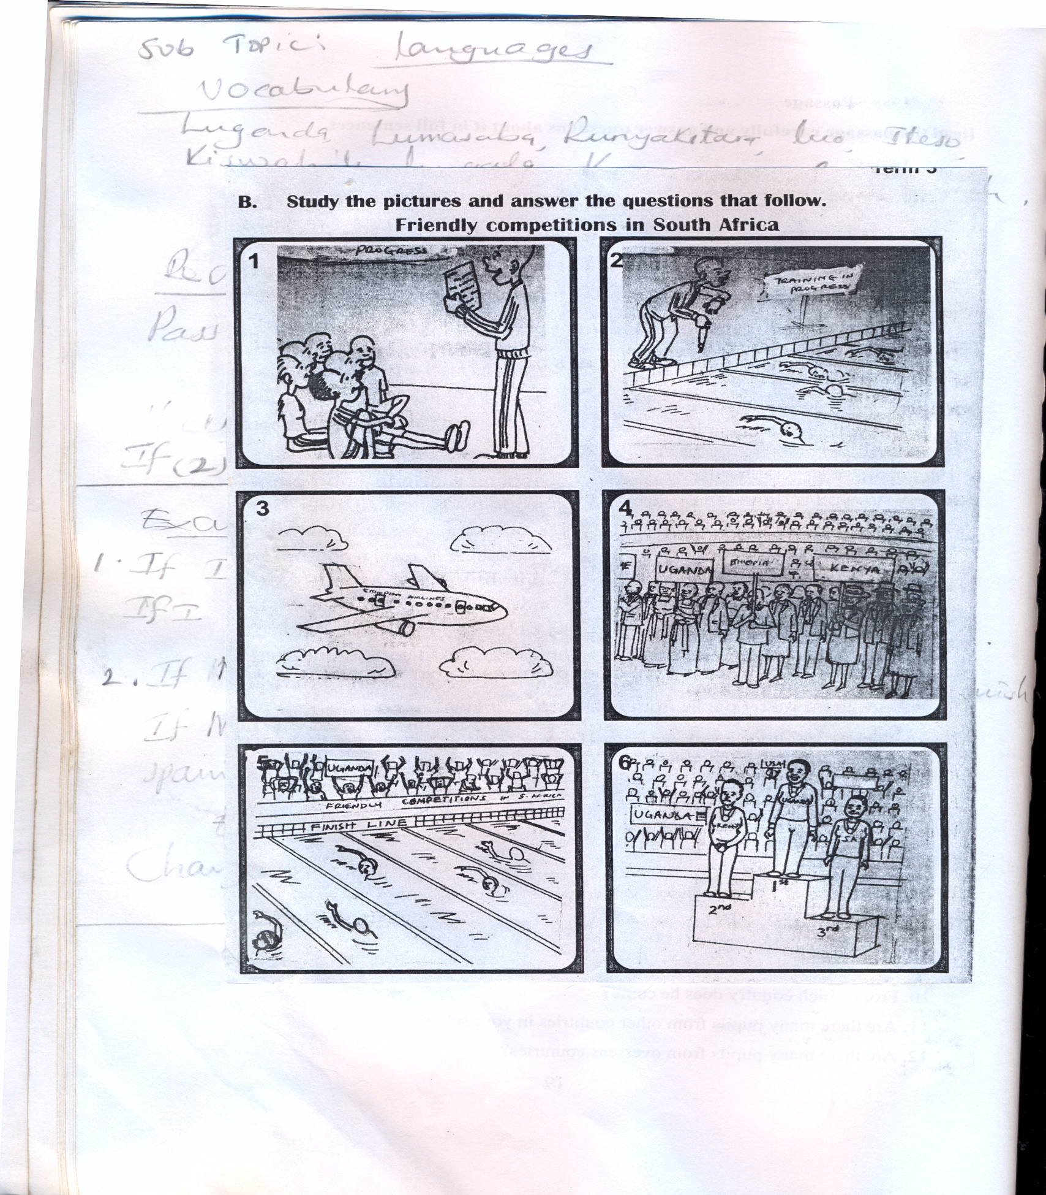

**Write correct sentence about each picture**

Picture 1

Picture 2

Picture 3

Picture 4

Picture 5

Picture 6

|  |  |  |  |  |
| --- | --- | --- | --- | --- |
| **Date** | **Time** | **Class** | **No. of pupils** | **Learning Area** |
|  |  | **P.5** |  | **English** |

**THEME : Culture**

**SUBTHEME : Languages**

**SKILLS : Listening, speaking, reading, writing**

**Vocabulary**

Luganda, Lumasaba, Runyakitura, Luo,

Iteso, Kiswahili, Luganda, Kinyarwanda,

French

**Revise**

**Passive voice**

**If (2)**

**Examples**

1. If I am a Nigerian, I will be rich.

If I were a Nigerian, I would be rich

1. If Muyyobu is from Spain, she will speak Spanish

If Muyyobu was from Spain, she would speak Spanish

**Exercise**

**Change these sentences to If(2)**

1. If I get money, I shall go to France
2. If they visit England, they will speak English.
3. If Peter flies to Europe, he will marry a European.
4. If she is an American, she will marry a Nigerian.
5. If he speaks German, he will study in Germany.
6. Fred will go to Cameroon if he passes his exams
7. Babra will be rich if she goes to Congo.
8. I shall play football if I am a Zimbabwean.
9. They will buy Japanese watches if they visit Japan.
10. Angume will not speak to those Moroccans if he meets them.